INTERNATIONAL ACADEMY FPT

FPT APTECH - HANOI 2
--o0o--


EMPLOYEE TRANSFER MANAGEMENT
Application name: ETMS
(Employee Transfer Management System)

Batch : C0909G
Faculty: Nguyen Duy Khuong
Group : 3
Member:
Ngo Xuan Thanh (Student434259) (Leader)
Doan Van Khang (Student477469)
Nguyen Xuan Thi (Student434210)
Do Manh Cuong (Student434125)
Hà nội 30/10/2010

Chapter I: Problem Definition 3
Problem Abstraction 3
The Proposed System 3
❖ Solutions: 3
❖ Employee Transfer Management system 4
❖ The application allows… 4
Chapter II: Customer Requirements Specification 4
Users of the System 4
❖ Project Objective: 4
❖ 2.1.1 Employee should be able to do the following: 4
❖ 2.1.2 Administrators should be able to do the following: 4
System functions 5
❖ Admin: 5
❖ Employee: 4
Hardware and Software Requirements 5
❖ Minimum Requirements 5
❖ Software requirements 5
Chapter III. Architecture & Design of Project 6
Entity-Relationship Diagram 6
3.1 Data Flow Diagram 6
3.2 Function Analysis 13
3.3 Flow chart: Include nine main functions 16
❖ Login: 16
❖ View Employee, Employee Manager 17
❖ Add new Employee: 18
❖ Edit Information 19
❖ Add New Transfer 20
❖ Approve Transfer 21
❖ Search 22
Chapter IV. System Design 24
4.1 Database Design 24
Chapter V. GUI Screenshot 24
Chapter VI. Task Sheet 24

Chapter I: Problem Definition

Problem Abstraction
ABC Technologies Ltd is a software production company. The transfer employees between positions, projects, departments are relatively much and also causes many difficulties in the management of personnel and materials involved in the company.
Currently the transfer records are maintained in the computer but there is no fixed format for.
Also the information is not shared by releasing circulars to the respective managers and employees and other related staff members (if any).
The information though maintained on computers, entire information cannot be found at single place. If higher management wants some details about the transfers, they have to get it from the respective department heads. This becomes time consuming.
Access to data is complicated, spend time.
Therefore, managers found that need to develop an application in order to overcome some limitations. The system will maintain information relating to staff transfer and make the transfer related documents, assist the management more convenient.
This application would be facilitating the system administrator (Higher Management) to search the employees transfer record, make new transfers and also amend the allowances offered to the employee, which usually depends on the post of the employee and the type of transfer he is getting.

The Proposed System

Solutions:
- Employees Transfer Management system manage all information. Data is archived centrally in database.
- Employee Transfer Management system is installed on all computers by employees, managers and assigned the access level.
- Employee Transfer Management system data systems login with account-level staff or managers.
- Employee Transfer Management system will limit the right to access data through the access level.
- Employee Transfer Management system allows to perform operations such as search, add new, update, cancel ,etc.

Employee Transfer Management system
Have 2 modules for 2 types of person:
- Administrator
- Employees

The application allows…
Application allows Employees can request for the transfer, delete, update the transfer request.
Administrators have access to manage all the information and approval for the requested transfer.
A GUI containing buttons, textboxes, labels…,
GUI containing buttons, textboxes, labels…, which will provide an user-friendly interface to the user to work with the application

Chapter II: Customer Requirements Specification

Users of the System

Project Objective:
- Users are Employee and Administrators.
- Creating a database general for users, employees and administrators to distinguish by role.

2.1.1 Employee should be able to do the following:
- Employees can view, search transfer records of individuals and update, delete transfer records has not been approved.
- Employees can request for the transfer.
- Employees can view and search for some personal information

2.1.2 Administrators should be able to do the following:
- Add information of employee
- Save/Edit any information of employees.
- Delete any employee. Before deleting a warning should be displayed so as to confirm and after deleting display message about deletion
- The Administrators should be able to search a employee by name.
- While adding/editing a Employee only required buttons should be enabled.
- Create, delete transfer records and approved transfer record.
- Generate the allowances; the employee will be entitled for based on the transfer location and his post.
- Generate transfer letters.
- Generate various reports like employees transferred in particular month / time span, transfers happened for particular projects etc.

Hardware and Software Requirements

Minimum Requirements
- 512 Megabytes of RAM or higher
- Pentium IV or higher capability CPU
- Windows 2000 (or higher if possible)
- Java Virtual Machine

Software requirements
- Java SE 5.0.
- NetBeans 5.5.
- MS SQL Server 2005
- JDBC, ODBC Driver

Chapter III. Architecture & Design of Project

3.1 Data Flow Diagram
Since the application will have a three – tier architecture

Figure 1: DFD LEVEL 0 - Context Diagram
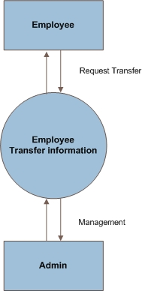

Figure 2: DFD LEVEL 1 – Application process
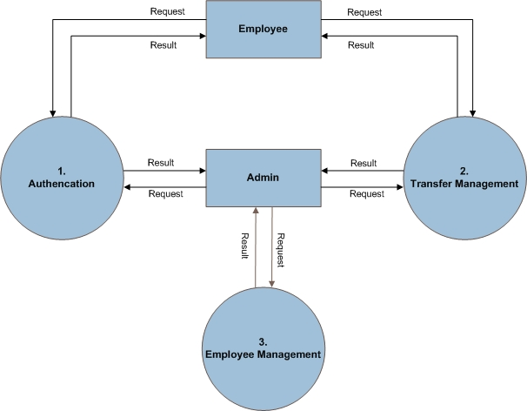

Figure 3: DFD Level 1.1. Login Admin - Level 1.2. Change password Admin
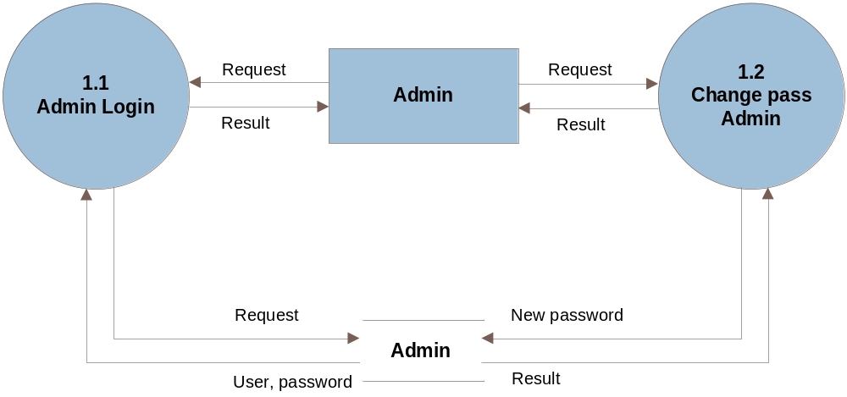
Figure 4: DFD Level 1.3. Login Employee - Level 1.4. Change password Employee
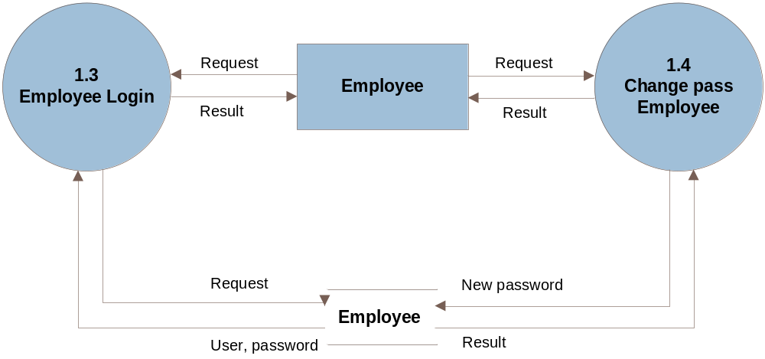

Figure 5: DFD Level 2.1. Search
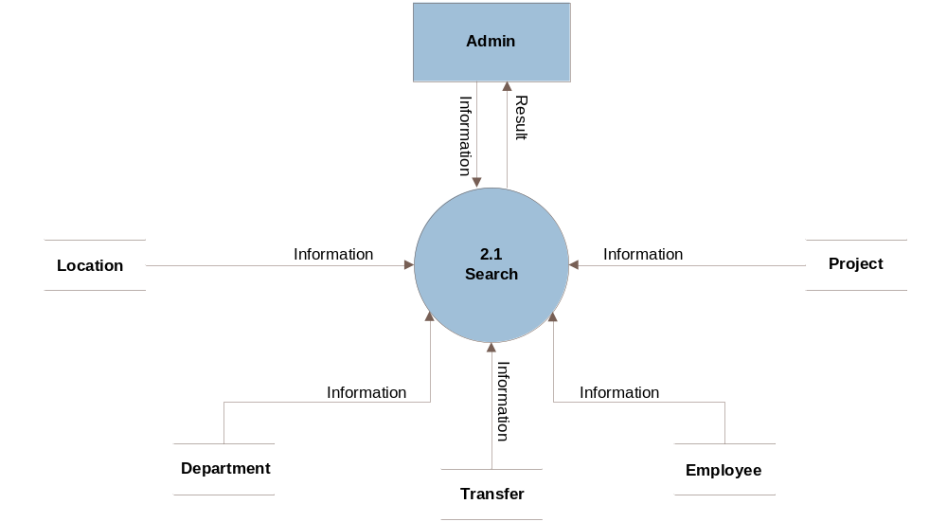
Figure 8: DFD Level 2.2.Approval

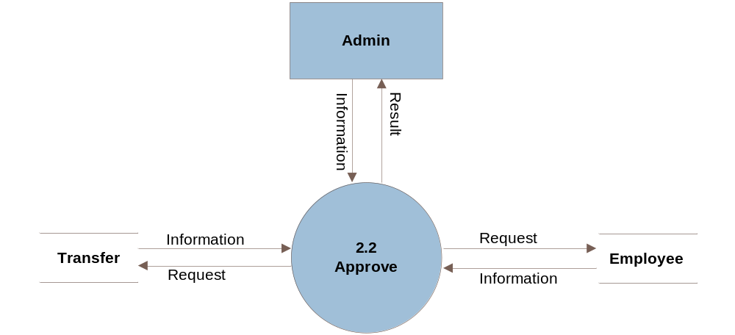

Figure 9: DFD Level 2.3.Location management - Level 2.4. Project management
– Level 2.5. Department management
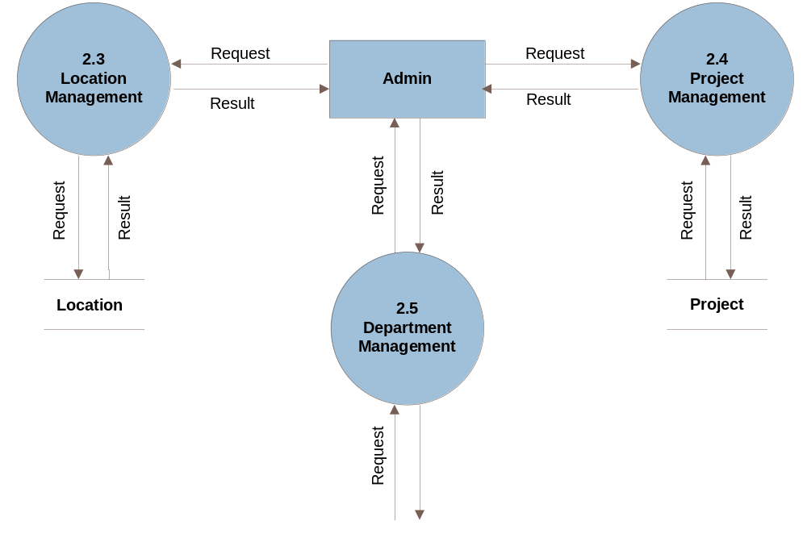
Figure 12: DFD Level 2.6. Transfer request management admin
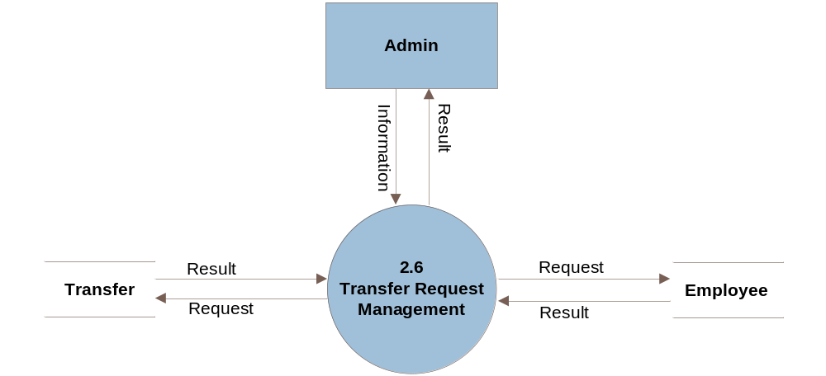
Figure 13: DFD Level 2.7. Transfer request management employee
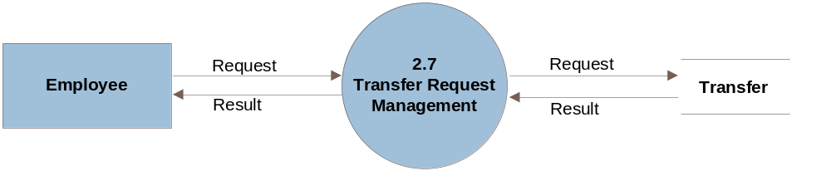
Figure 14: DFD Level 3.1. Employee management

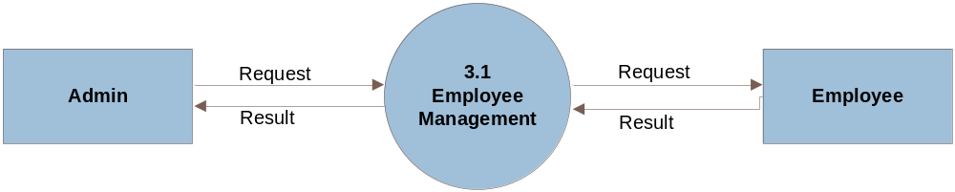

3.2 Function Analysis
Administrator

USE CASE # | 1
USE CASE Name | Addministrator
ACTOR | Manager
Purpose | Login, search, Manage information of employees, manage transfer records, manage location, manage project, manage department.
Activate | when users login the Administator
Pre-conditions | when users login the Administator
Descriptions | When user login the Administator (Transfer Manager,Employee Manager,Location Manager ,Department Manager,Project Manager) for users to choose
Other Comments

Transfer Manager

USE CASE # | 2
USE CASE Name | Transfer Manager
ACTOR | Manager
Purpose | Search Information of Transfer Manager
Activate | when users click on the Transfer Manager
Pre-conditions | User must click on the Transfer Manager
Descriptions | - Status::  - Click select (all,wait,approve,notapprove),  - Employee:  - Click select all userName Employee  - FormLocation:  - Click select all FromLocation(add old)  - FormDepartment:  - Click select all FormDepartment (add old)  - FormProject:  - Click select all FormProject (add old)  - ToLocation:  - Click select all ToLocation (add new)  - ToDepartment:  - Click select all ToDepartment (add new)  - ToPorject:  - Click select all ToPorject (add new)
Other Comments

Employee Manager
USE CASE # | 3
USE CASE Name | Employee Manager
ACTOR | Manager
Purpose | Search Information of Employee Manager
Activate | when users click on the Employee Manager
Pre-conditions | User must click on the Employee Manager
Descriptions | - Employee:  - Search EmployeeName:  - Writer EmployeeName  - Location:  - Select by(all,or Location)  - Department:  - Select by(all,or Department)  - Project:  - Select by(all,or Project)
Other Comments

Location Manager

USE CASE # | 4
USE CASE Name | Location Manager
ACTOR | Manager
Purpose | Search Information of Location Manager
Activate | when users click on the Location Manager
Pre-conditions | User must click on the Location Manager
Descriptions | - Location Address:  - Writer Address  - Click button search
Other Comments

Department Manager
USE CASE # | 5
USE CASE Name | Department Manager
ACTOR | Manager
Purpose | Search Information of Department Manager
Activate | when users click on the Department Manager
Pre-conditions | User must click on the Department Manager
Descriptions | - Department Name:  - Writer Address  - Click button search
Other Comments

Project Manager

USE CASE # | 6
USE CASE Name | Project Manager
ACTOR | Manager
Purpose | Search Information of Project Manager
Activate | when users click on the Project Manager
Pre-conditions | User must click on the Project Manager
Descriptions | - Search:  - Writer Address  - Click button search
Other Comments

3.3 Flow chart: Include nine main functions

Login:
- Actors: Employee or Admin
- Description:
- Input user and password will connected to database
- Check entry of User and Password (Validations) .If correct display management page ,if incorrect display Error message. User and password in database >>>Login Successfully.
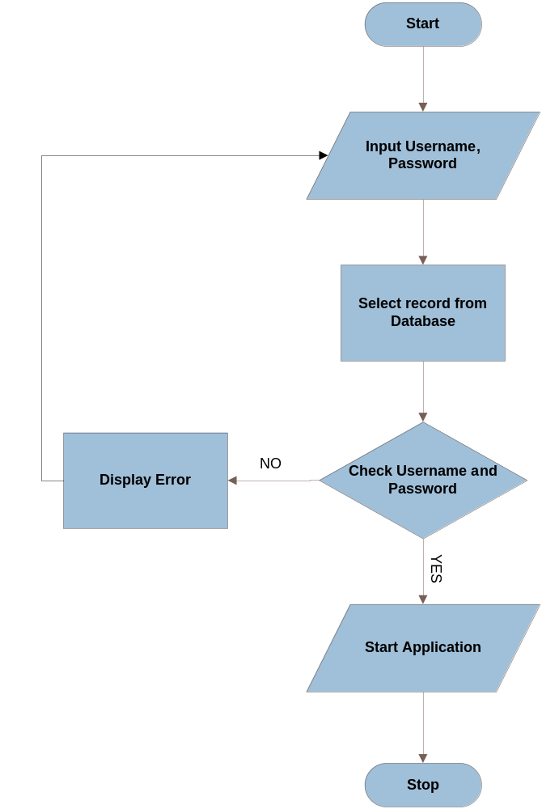

View Employee, Employee Manager
- Actors: Admin
- View: Can display Employee Name, Employee Id, from Location to Locationor from project to project or from department to department.
- Description:
- Select record , Click button View it will be connect to database.
- Display your view information.
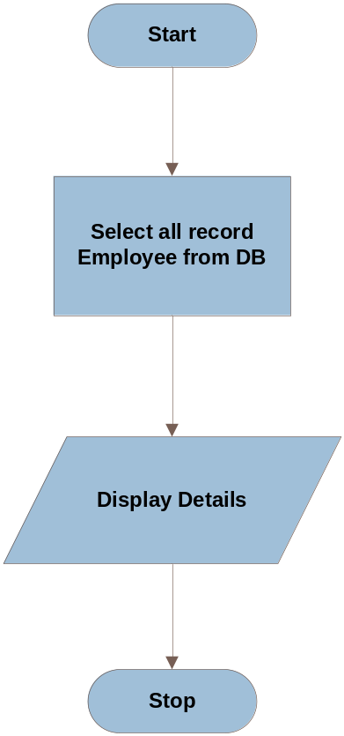

Add new Employee:
- Actors: Admin
- Add new user: Have functions into Name Employee, EmpID Employee, Email Employee, Address Employee…
- Description:
- Into information .
- Check exist EmpID.
- Display information your into.
into and check valid information, if data is existed it will appear a dialog message “Employee is existed in table”.
- If data is valid it will be into in database >>>Add new sucessfully.
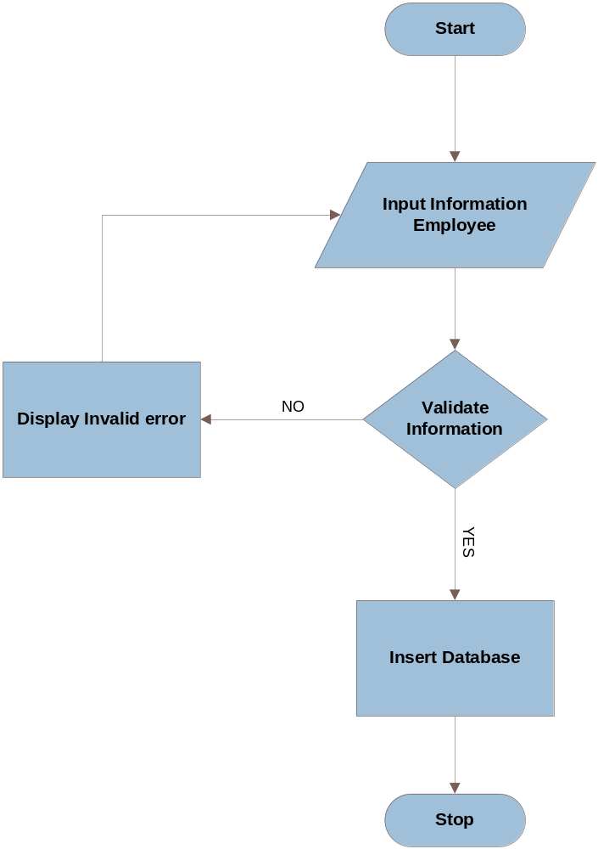

Edit Information
- Actors: Employee
- Edit: Have functions edit Name Employee, EmpID Employee, Email Employee, Address Employee…
- Description:
- Select record.
- Check exist EmpID.
- Display information your update.
- Edit and check valid information, if data is not valid it will appear a dialog message “Data invalid”.
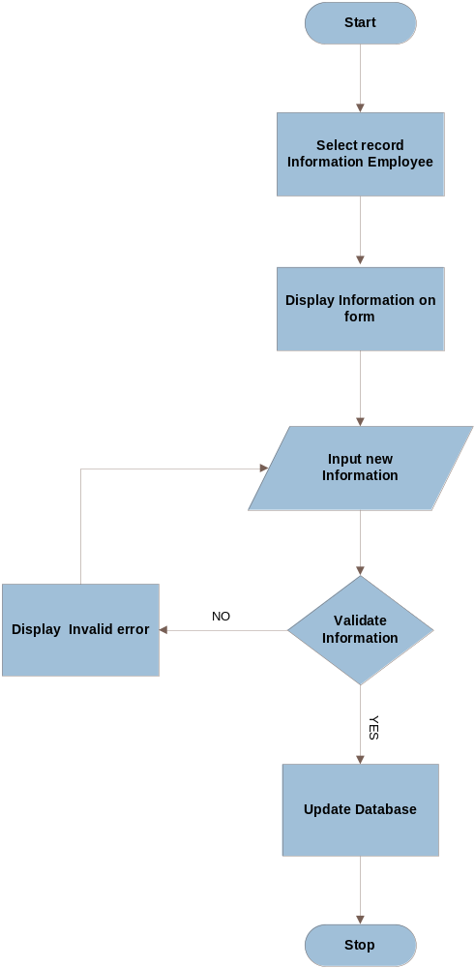

Add New Transfer
- Actors: Admin
- Add new transfer: Have functions into Employee Name, Employee Id, from Location to Location or from project to project or from department to department …
- Description:
- Select a Employee Name from list after into from location to location or from project to project of department to department
- Check exist Transfer ID.
- Display information your add.
- Into and check valid information, if data is existed it will appear a dialog message “The transfer is transferred ”.
- If data is valid it will be into in database >>>Add new transfer successfully
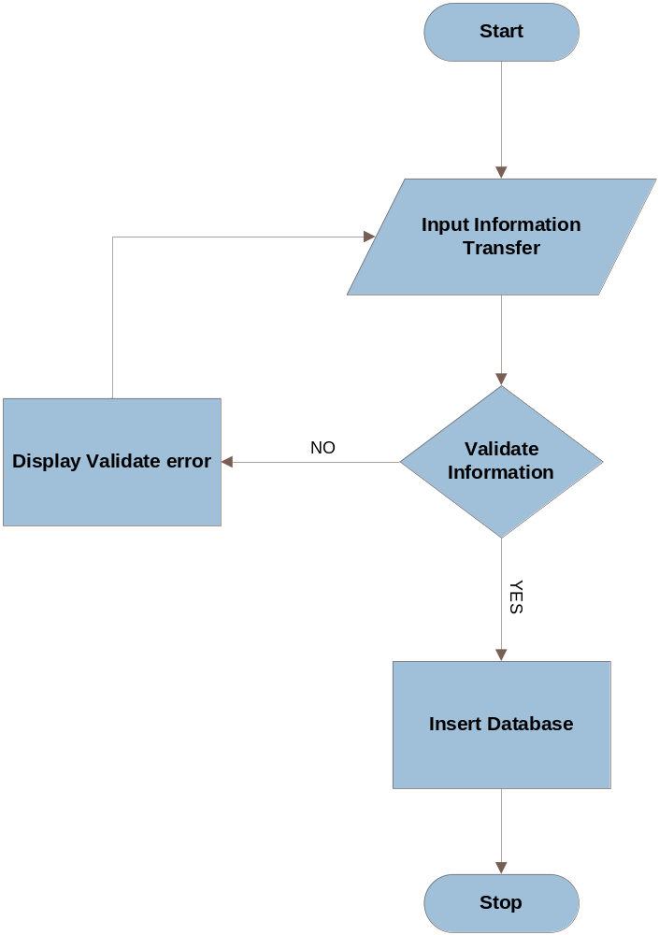

Approve Transfer
- Actors: Admin
- Approved: approved the transfer of employee
- Description:
- Display list of transfer after click accepted button or refused button
- Check event
- Connect with database
- If click accepted will appear a dialog message “you are accepted for Employee, after send message to Employee accepted, else click refused button will appear a dialog message “You are refused for Employee”, after send message to Employee refused
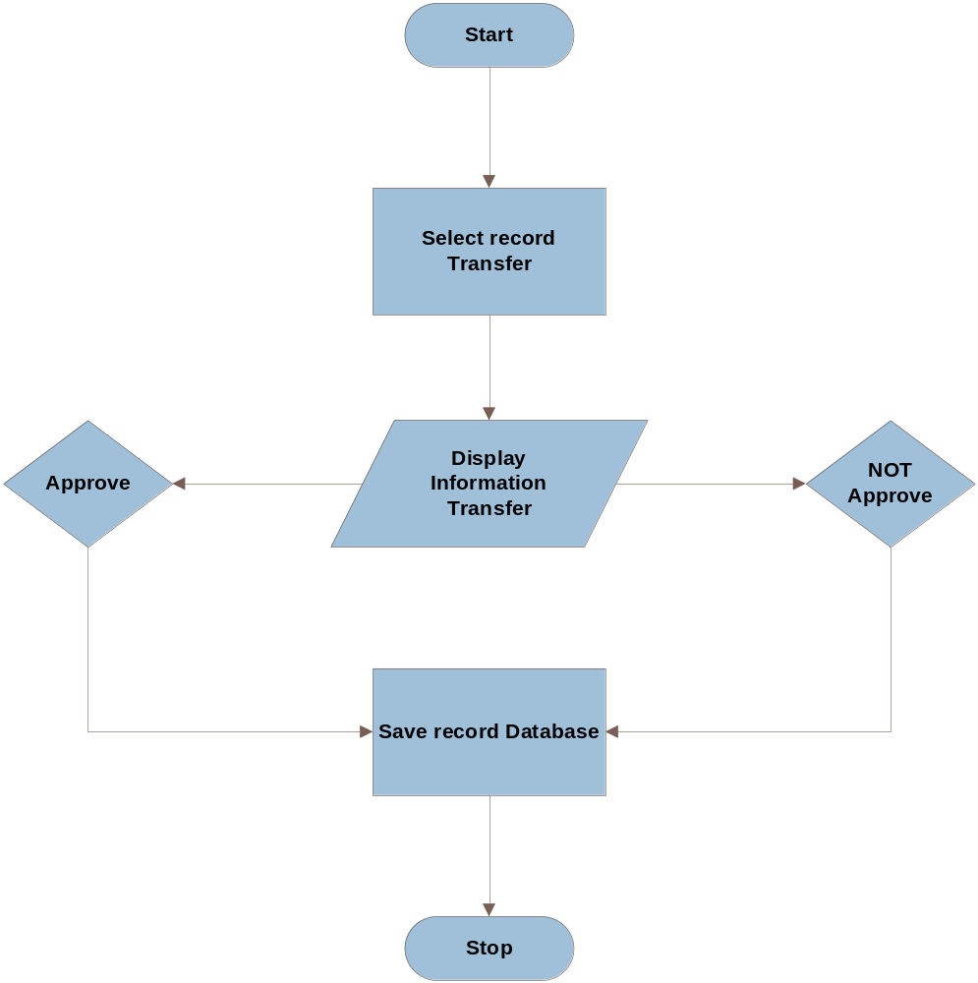

Search
- Actors: Employee, Admin
- Search: This is tool search Number, Name ,Location ,Project ,Department of Employee…
- Description:
- Input your search information.
- Check data is input.
- Connect database.
- If data is not exist it will appear a dialog message “There is no data your search”.
- If data is exist, it will display your search information

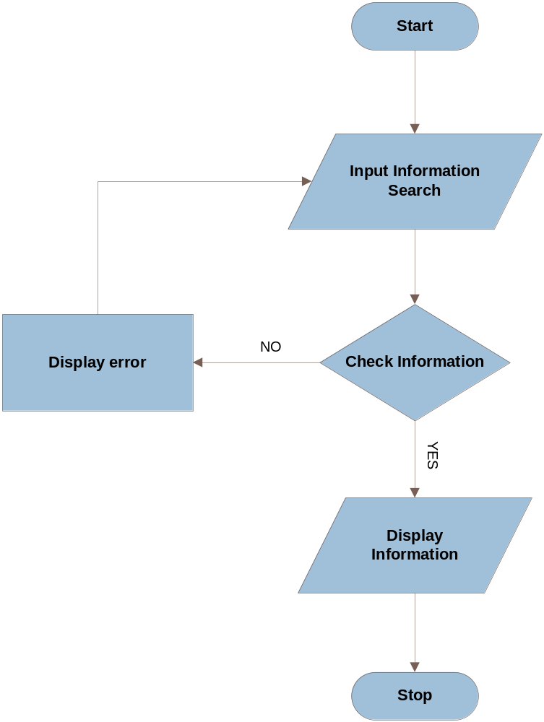

Entity-Relationship Diagram
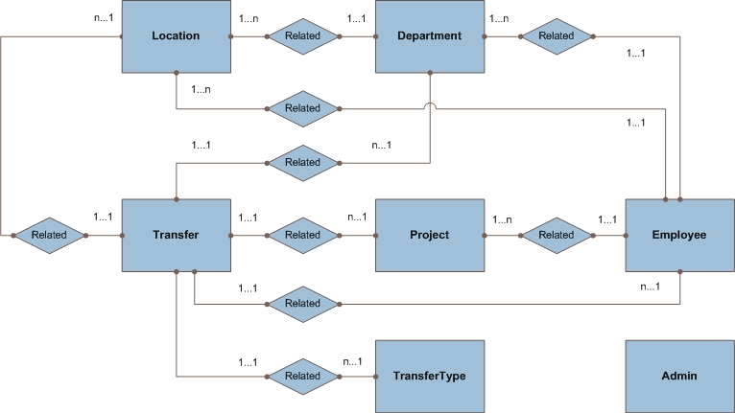

Chapter IV. System Design

4.1 Database Design
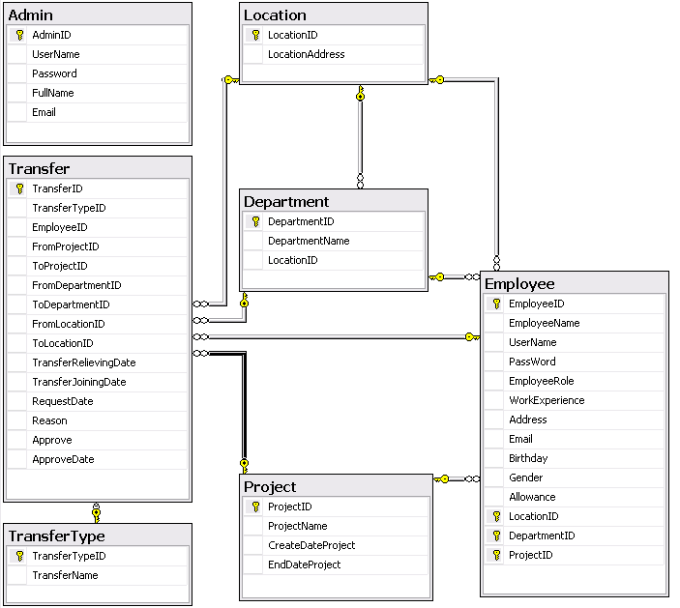

- Table Admin

Field Name | Data Type | Allow Null | Key | Description
AdminID | Int, identity(1,1) | Not null | PK | Store Amind ID
Username | Nvarchar(50) | Not null |  | Store user name
Password | Nvarchar(100) | Not null |  | Store password
FullName | Nvarchar(50) | Not null |  | Store FullName
Email | Nvarchar(50) | Not null |  | Store Email

- Department
Field Name | Data Type | Allow Null | Key | Description
DepartmentID | Int, identity(1,1) | Not null | PK | Store Department ID
DepartmentName | Nvarchar(100) | Not null |  | Store DepartmentName
LocationID | Int | Null |  | Store LocationID

- Employee
Field Name | Data Type | Allow Null | Key | Description
EmployeeID | Int, identity(1,1) | Not null | PK | Store Employee ID
EmployeeName | Nvarchar(50) | Not null |  | Store Employee Name
UserName | Varchar(100) | Not null |  | Store user name
PassWord | Varchar(100) | Not null |  | Store password
EmployeeRole | Nvarchar(100) | Not null |  | Store Employee role
WorkExperience | int | Null |  | Store work Exeprience
Address | Nvarchar(100) | Not null |  | Store address
Email | Nvarchar(50) | Not null |  | Store Email
Birthday | Datetime | Null |  | Store birthday
Gender | Nvarchar(20) | Null |  | Store Gender
Allowance | Float | Null |  | Store Allowance
LocationID | Int | Not null |  | Store Location ID
DepartmentID | Int | Not null |  | Store Department ID
ProjectID | Int | Not null |  | Store Project ID

- Table Location

Field Name | Data Type | Allow Null | Key | Description
LocationID | Int, identity(1,1) | Not null | PK | Store Location ID
LocationAdress | Nvarchar(100) | Not null |  | Store Location Address

- Table Project

Field Name | Data Type | Allow Null | Key | Description
ProjectID | Int, identity(1,1) | Not null | PK | Store Project ID
ProjectName | Nvarchar(50) | Not null |  | Store Project name
CreateDateProject | Datetime | Not null |  | Store create date project
EndDateProject | Datetime | Not null |  | Store end date project

- Table Transfer

Field Name | Data Type | Allow Null | Key | Description
TransferID | Int, identity(1,1) | Not null | PK | Store Transfer ID
TransferTypeID | Int | Not null |  | Store Transfer Type ID
EmployeeID | Int | Not null |  | Store Employee ID
FromProjectID | Int | Not null |  | Store FromProjectID
ToProjectID | Int | Not null |  | Store ToProjectID
FromDepartmentID | Int | Not null |  | Store FroDepartmentID
ToDepartmentID | Int | Not null |  | Store ToDepartmentID
FromLocationID | Int | Not null |  | Store FromLocationID
ToLocationID | Int | Not null |  | Store ToLocationID
TransferRelievingDate | datetime |  |  | Store TransferRelie
TransferJoiningDate | datetime |  |  | Store TransferRelie
RequestDate | datetime | Not null |  | Store RequestDate
Reason | nvarchar(100) |  |  | Store Reason
Approve | nvarchar(30) |  |  | Store Approve
ApproveDate | datetime |  |  | Store ApproveDate

- Table TransferType
Field Name | Data Type | Allow Null | Key | Description
TransferTypeID | Int, identity(1,1) | Not null | PK | Store Transfer Type ID
TransferName | Nvarchar(100) | Not null |  | Store Transfer Name

Chapter V. GUI Screenshot

Login
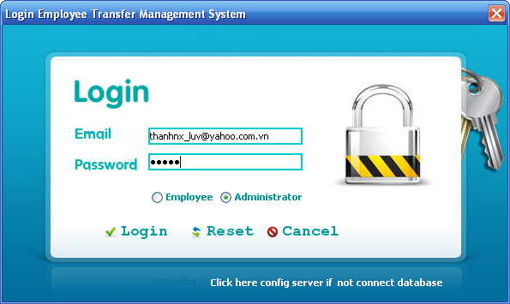
Config
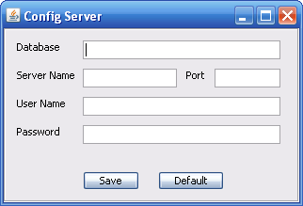
Change pass Admin
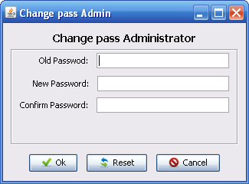
Change pass Employee
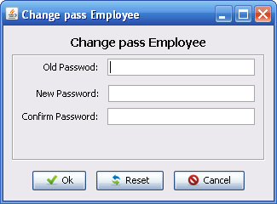

Main Admin Interface
Home tab
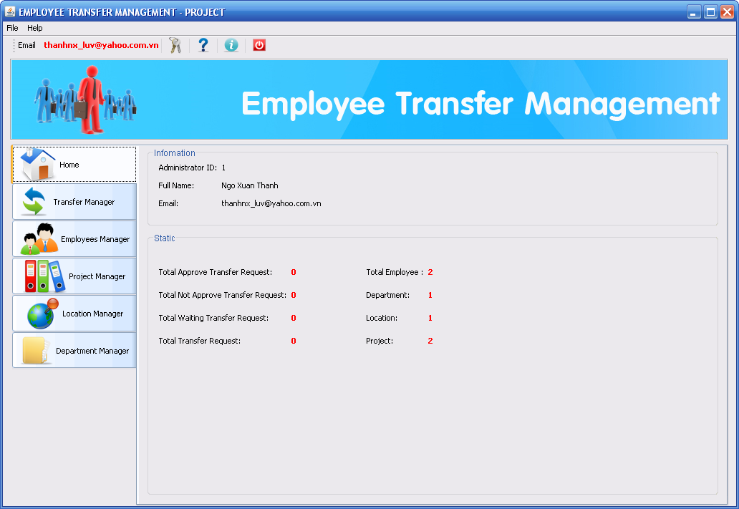

Transfer tab
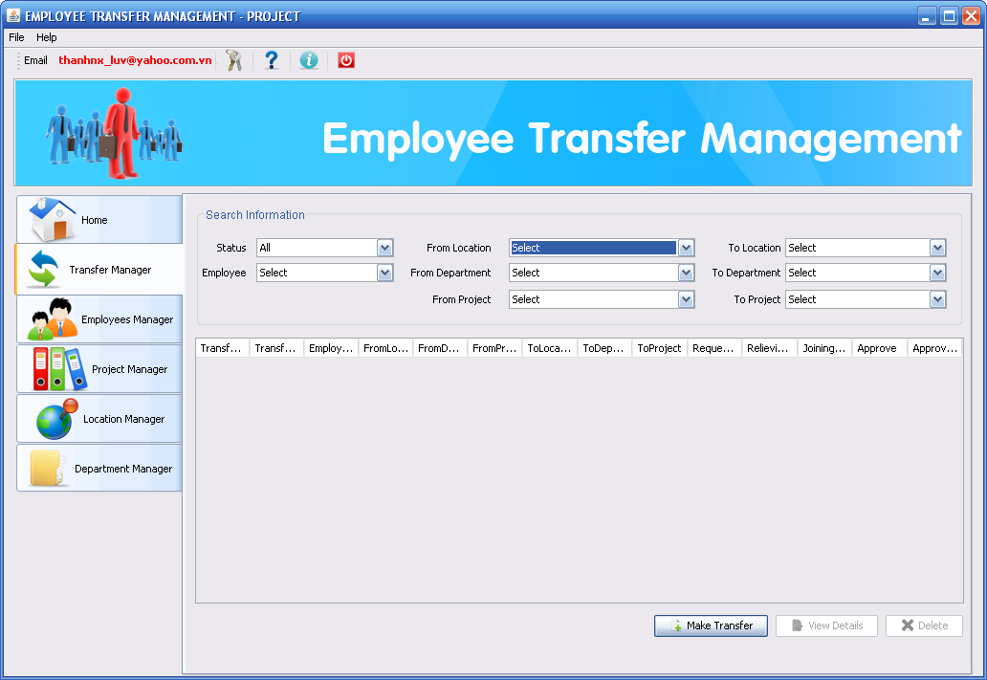
Mark new transfer
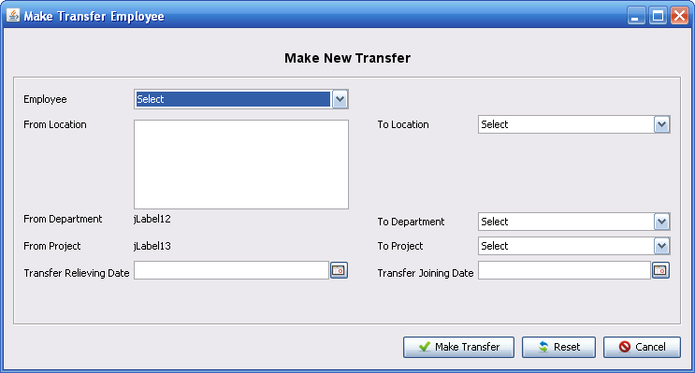
Employee tab
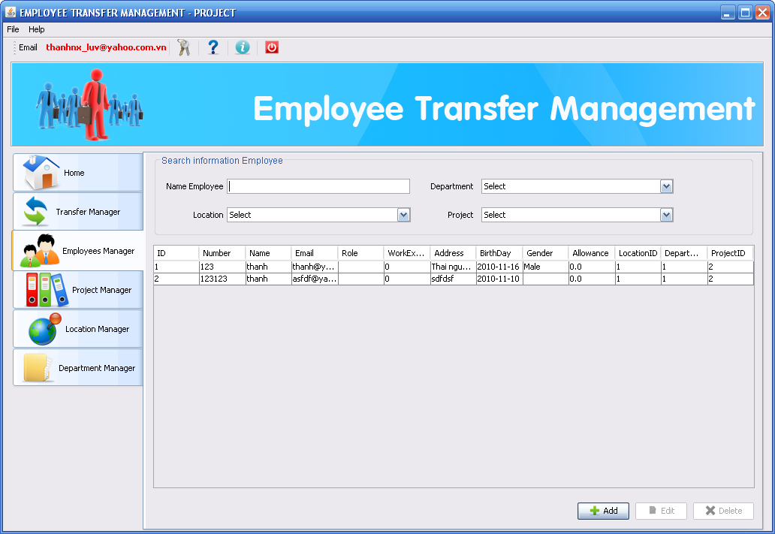
Add new Employee
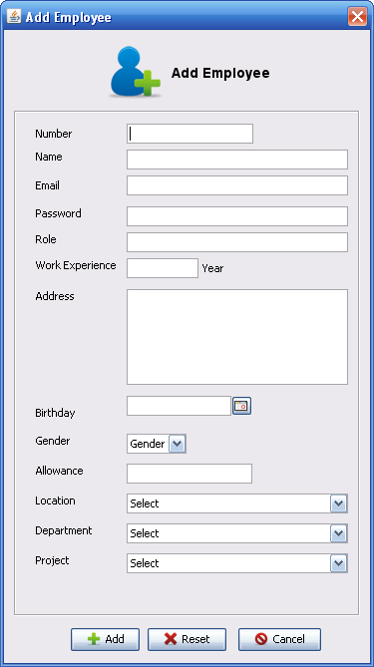
Edit employee
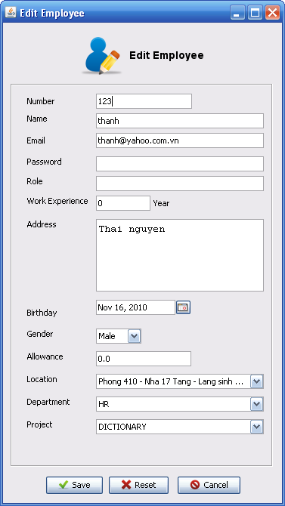
Project tab
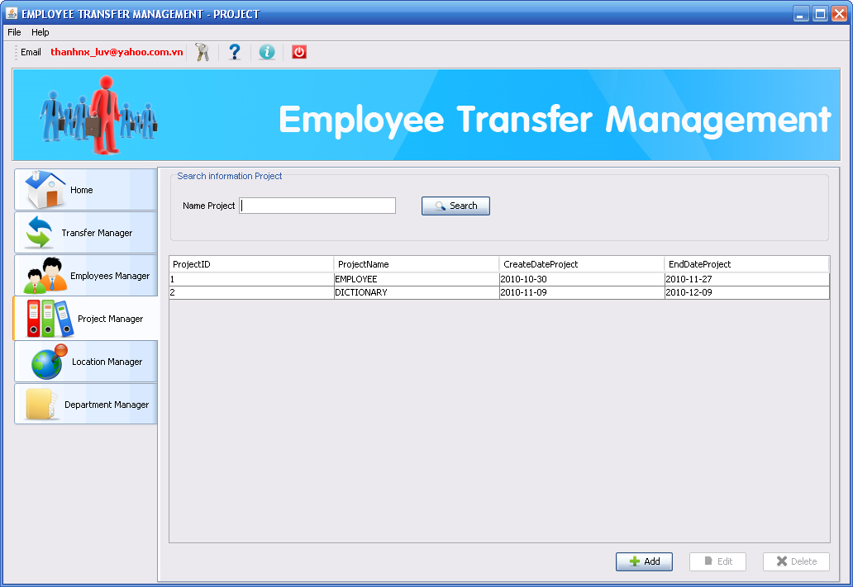
Add new Project
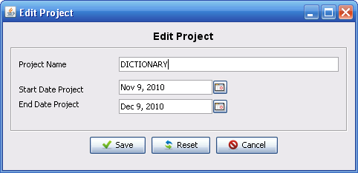
Edit Project
Location tab
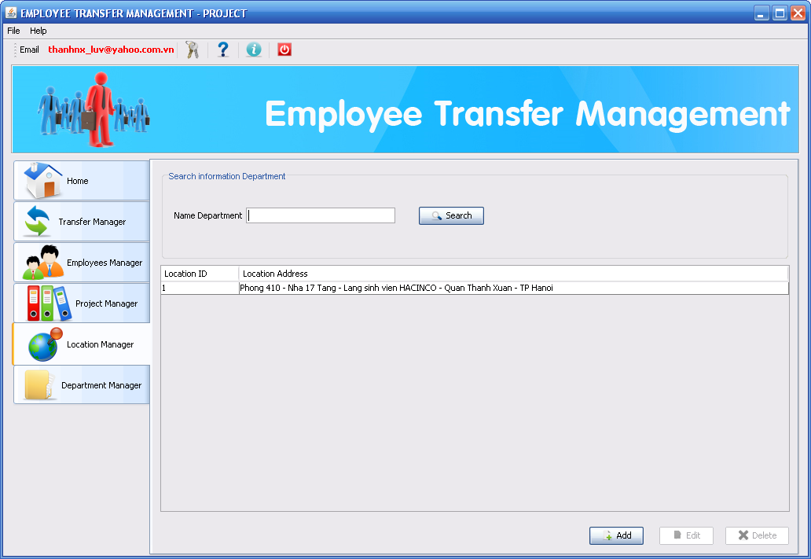

Department tab
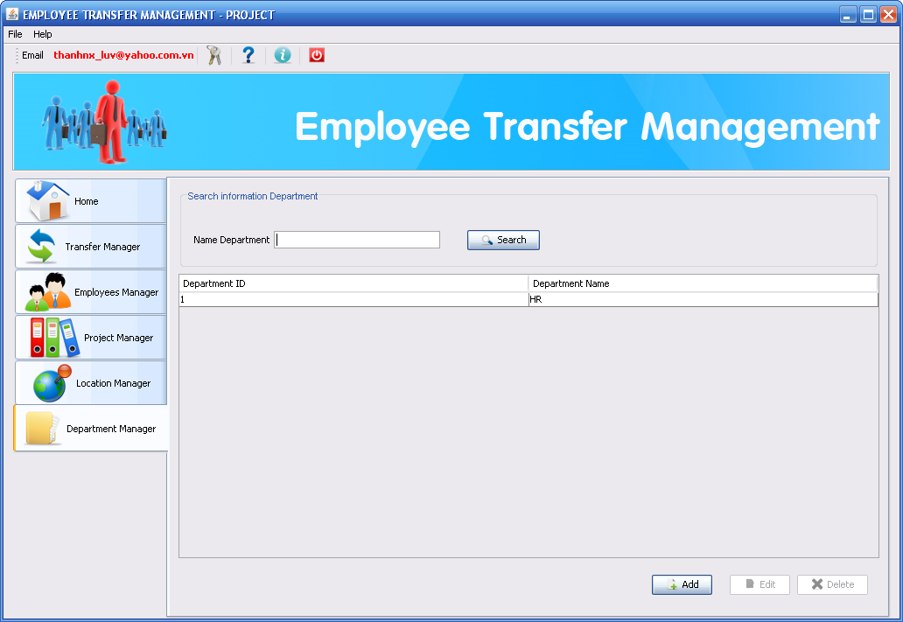
Add new Department
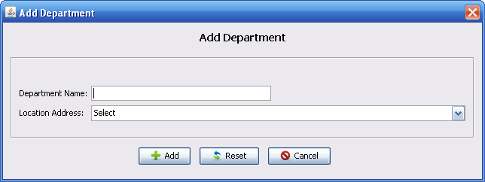
Edit Department
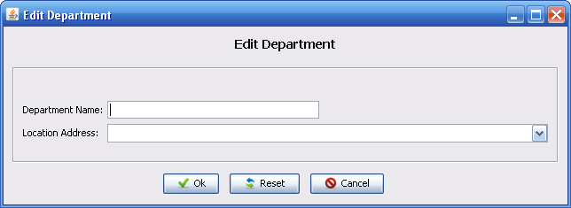

Transfer details

Main Employee Interface
Home tab
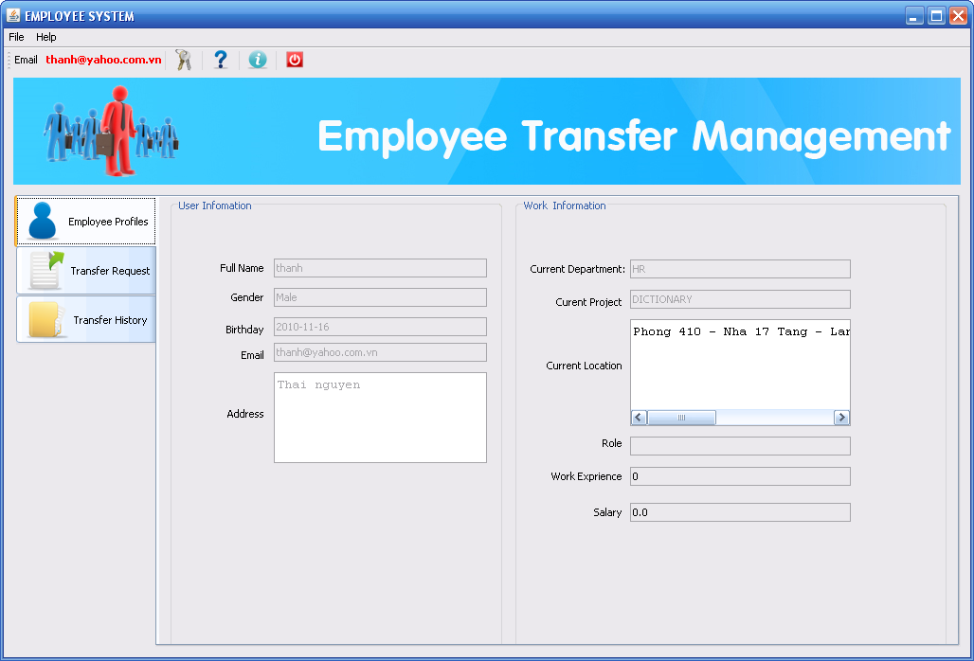
Transfer tab
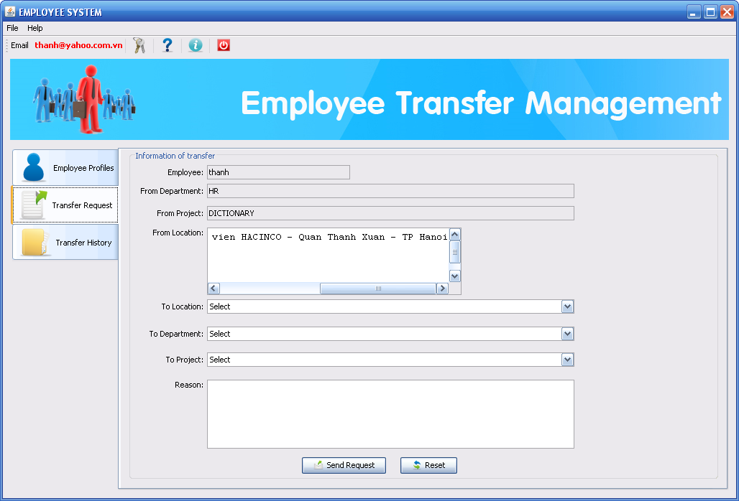
History tab
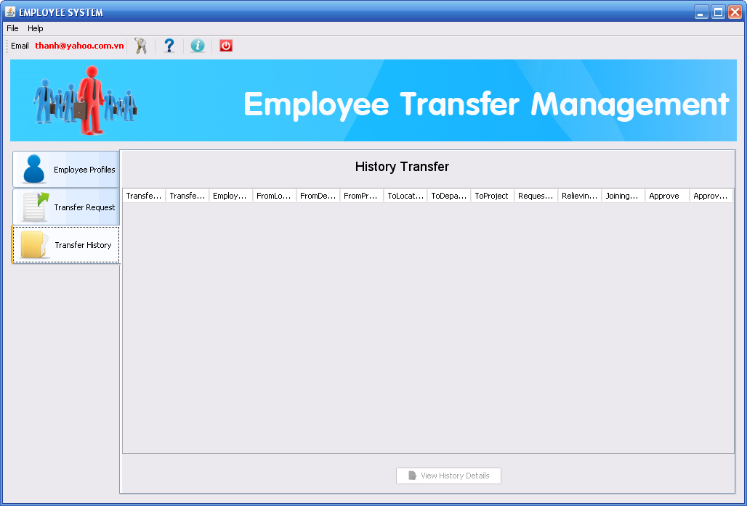
View History
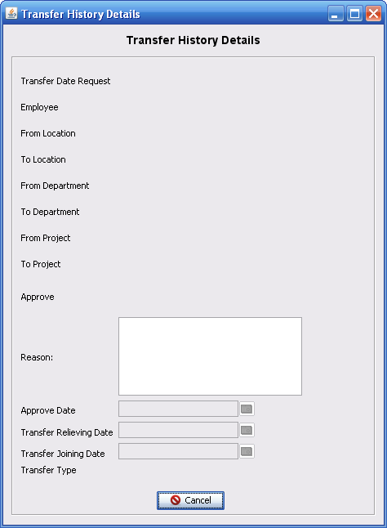

Chapter VI. Task Sheet

Project Ref. No: |  | Project Title | Activity Plan  Prepare By | Date of Preparation of activety Plan
Sr.No | Task | Project Title | Activity Plan  Prepare By | Actual Start Date | Actual Days | Team Members Names | Status
1 | Application Development | ETMS |  | 30/10/2010 | 7 | Ngo Xuan Thanh  Doan Van Khang  Nguyen Xuan Thi  Do Manh Cuong | complete
2 | Database Design | ETMS |  | 30/10/2010 | 7 | Ngo Xuan Thanh | complete
3 | Design GUI | ETMS |  |  | 5 | Ngo Xuan Thanh  Doan Van Khang  Nguyen Xuan Thi  Do Manh Cuong | complete
4 | - Module Transfer  Send request  View history  Makes new transfer  Search information  - Modules Employee  View  Add  Edit  Search | ETMS |  | 07/11/2010 | 15 | Ngo Xuan Thanh | complete
5 | Module Department  View  Add  Edit  Search | ETMS |  | 19/11 | 9 | Do Manh Cuong | complete
6 | Module Location  View  Add  Edit  Search | ETMS |  | 19/11 | 9 | Do Manh Cuong | complete
7 | Module Project  View  Add  Edit  Search | ETMS |  | 22/11 | 12 | Doan Van Khang | complete
8 | - Login Admin  - Change pass Admin  - Login Employee  - Change pass Employee |  |  | 20/11 | 10 | Nguyen Xuan Thi

